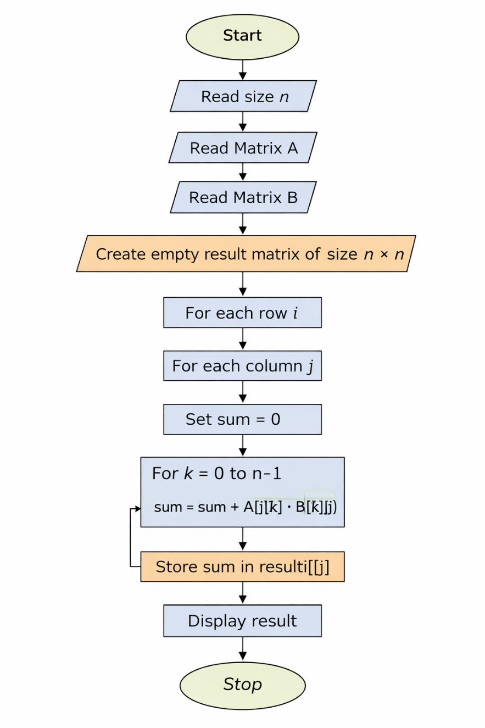
ALGORITHM
- Start
- Read size n
- Read matrix A
- Read matrix B
- Create empty matrix result of size n × n
- For each row i
- For each column j
- Set sum = 0
- For k = 0 to n-1
- sum = sum + A[i][k] × B[k][j]
- Store sum in result[i][j]
- Display result
- Stop

8.1.1 MULTIPLICATION OF 2 SQ. MATRICES

